Rainwater Management
Sustainable Water Fund
Application Form

Sustainable Water Fund
The Sustainable Water Fund is a new initiative building on previous successful partnerships to support local authorities across the North West in delivering sustainable solutions to the challenges of managing rainwater by slowing and stopping it entering combined sewer systems.
This is an exciting opportunity to deliver rainwater management solutions through collaborative investment. By managing rainwater where it falls, together, we can transform our towns and cities to create a stronger, greener and healthier North West.
This fund empowers us to work as a partnership to:
💧 Remove rainwater from combined sewer systems
🏞️ Retrofit and expand Sustainable Drainage Systems (SuDS)
🌧️ Contribute to the reduction of storm overflow spills and flood risk
🧑‍🤝‍🧑 Enhance local biodiversity, climate resilience and wellbeing.

We’ve previously invested almost £10m into over 15 projects across the North West during our Green Recovery Programme, enhancing natural capital by over £50m.

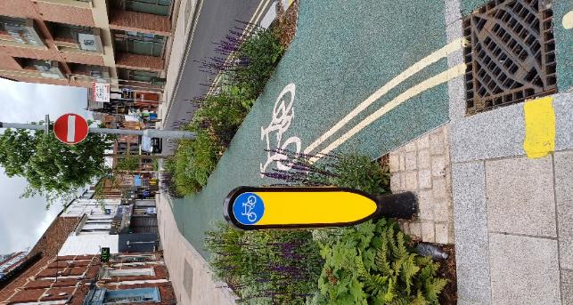
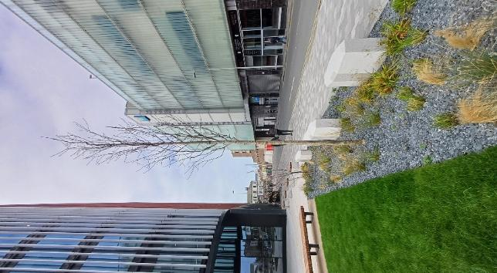
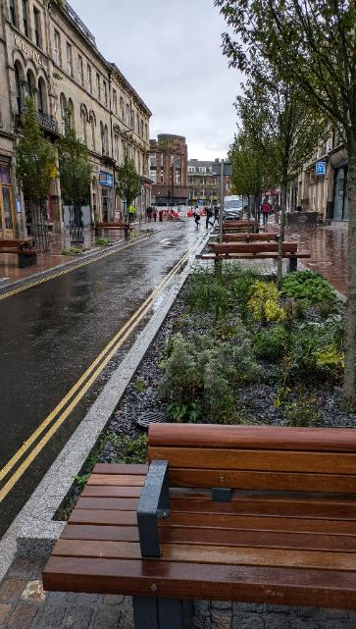
Apply below to become part of a transformative programme where water resilience is built not in isolation, but through partnership, innovation, and nature-led design.
Raingardens in Altrincham, Trafford

A new green travel corridor in Carlisle

242 sustainable drainage street trees across Blackpool

Pre-Application Information

Before you complete the full application form, here’s everything you need to know about the fund & eligibility. To be eligible for funding, projects must align to some key rules and tests.

Step 1: Does your project meet the required conditions?
- Projects must remove or attenuate surface water entering a combined sewer
- Projects must have at least 20% of project funded from other sources e.g. GiA, LUF
- Projects must be submitted by a local authority
- Projects must have achieved practical completion by 31/12/2029
- Projects must not already be in construction or be fully funded
- Projects must use Sustainable Drainage Systems (SuDS), Natural Flood Management (NFM) and / or disconnection
- Projects must publish relevant information to support industry learning
- Projects must use the standard funding agreement enclosed to claim funding
- Projects must agree to funding and undertaking maintenance of features that are not sewers

If your project fails to meet all the conditions listed above, unfortunately you are not eligible for the Sustainable Water Fund. This does not necessarily mean that UU cannot be involved and support, so please reach out via rainwater@uuplc.co.uk and we can discuss how we can be flexible to work with you and review eligibility for other rainwater management schemes or partnership opportunities.
If your project is in: Kendal, Lancaster, Preston, St Helens, Glossop or Hazel Grove, please do not fill out an application form and get in touch with us via rainwater@uuplc.co.uk. We are undertaking specific projects to reduce flooding and therefore will include these within our Climate Resilience programme.

Step 2: Understanding whether your project will be successful
As part of evaluating your project, we will be assessing:
- Is the project within an overflow with a 2031-2050 target date in the Storm Overflow Discharge Reduction Plan (SODRP), and is not within the drainage area for an overflow with a 2025-2030 target date?
- If you’d like to see where some of the priority overflows within your area are, please get in touch with us and we can share these areas with you.
- If you have specific locations you would like to review before application, we can check a limited number of specific locations.

- Is the project removing or reducing surface water draining to the combined sewer, and does that contributes towards our 10 spill target?

- Is the project request less than our maximum rate of £50/m2 where disconnection is achieved?

UU holds the discretion to decide what to fund, and the value of funding on a case-by-case basis.

If you would like to discuss any of the information above, please contact rainwater@uuplc.co.uk.

Application Information

Project Details
Project Title:
Easting:
Northing:
Postcode:
Council
Department
Lead Contact Name:
Lead Contact Email:
Lead Contact Number:
Lead Contact Role:

Project Summary
Information | Evidence
Project Summary

Please include any supporting information on wider benefits in this section.

What are the anticipated risks and opportunities to meeting the project to time, cost and quality?

How might partnering with UU overcome any of these?

Funding
If you have secured, or are in the process of securing, additional partner funding for this project, please detail this below.

Attachment Details
Fill in the table below so that we know what attachments to expect with your application. If you have any issues uploading your files on the application portal, inform us via rainwater@uuplc.co.uk.
Document | Yes / No | Further Information
Project Plan and/or GIS shapefile
Evidence of Connectivity (e.g. survey results or survey records)
Maintenance statement
Supporting information regarding wider benefits
Other

Project Information

Key Information
Question | Response
Disconnection, attenuation or both?
Pre-project area draining to the combined sewer (m2)
Post-project area draining to the combined sewer (m2)
Is a connectivity survey required?

Maximum total storage volume created for new SuDS attenuation features (m3)

Proposed outlet flow control rate (l/s)

Natural Flood Management Area
NFM must also include disconnections where there is no direct connection to combined sewers.
What is the total cost of your project?
What is the cost of the rainwater management features?
What is the contribution requested from UU?
What elements will the UU contribution allow to be delivered?

Evidence of Connectivity
We will need to physically confirm positive connections to the combined sewer to fund projects, so please attach any existing information that confirms assumptions such as site photographs, GIS records, drainage plans, connectivity surveys, dye tests, survey records or any other evidence clearly demonstrating this. Please outline the scope of the required connectivity surveys if this has not been completed.
You may attach these as files with your application or copy images below. Please note that attachments must not exceed 8MB.
Has the project had connectivity surveys completed? (Yes / No)
Yes / No
Attachments

Solution Types
Select the solution types included in your project.
SuDS | Yes / Blank | Reuse | Yes / Blank
Green Roofs |  | Rainwater Harvesting System
Infiltration Systems
Proprietary Treatment Systems |  | NFM
Filter Strips |  | Upland peat management
Filter Drains |  | Soil and land management
Swales |  | Runoff management
Bioretention Systems |  | Runoff storage, catchment woodland
Pervious Pavements |  | Cross slope woodland
Street Trees |  | Riparian woodland
Attenuation Storage Tanks |  | Floodplain woodland
Detention Basin |  | Leaky barriers
 |  | Offline storage
Disconnection |  | Floodplain reconnection
Surface Water Sewer |  | Channel restoration
Watercourse
Highway Drainage

Project stage dates (where applicable)
Project Stage (RIBA Stage) | Start Date | End Date | Confirmed? Please mark if the project stage dates are indicative or set.
Initiation (0: Strategic Definition)
Masterplan (0: Strategic Definition, 1: Preparation and Briefing & 2: Concept Design)
Feasibility (1: Preparation and Briefing)
Outline Design (2: Concept Design & 3: Spatial Co-ordination)
Detailed Design (4: Technical Design)
Construction (5: Manufacturing/ Construction, 6: Handover and 7: Use)
Please add any supporting comments about the project timeline here:

Ownership and Maintenance
Comment
What is the ownership and maintenance plan?
Are you intending on retaining ownership of the features in the land as it is currently? If not, please provide details of who landowner(s) are and intended agreements / agreements already in place.
United Utilities will not maintain features funded through the Sustainable Water Fund unless they are classed as public sewers.
Please attach a maintenance statement to your application where applicable.
Is planning permission required for this project?

Is it anticipated that any other consenting may be required for the project?

Supporting Information
If you would like to attach any further information to help us learn more about your project, please detail this below and note any additional attachments to the ‘Attachment Details’ Table.

United Utilities Water Limited
Haweswater House
Lingley Mere Business Park
Lingley Green Avenue
Great Sankey
Warrington
WA5 3LP
unitedutilities.com

